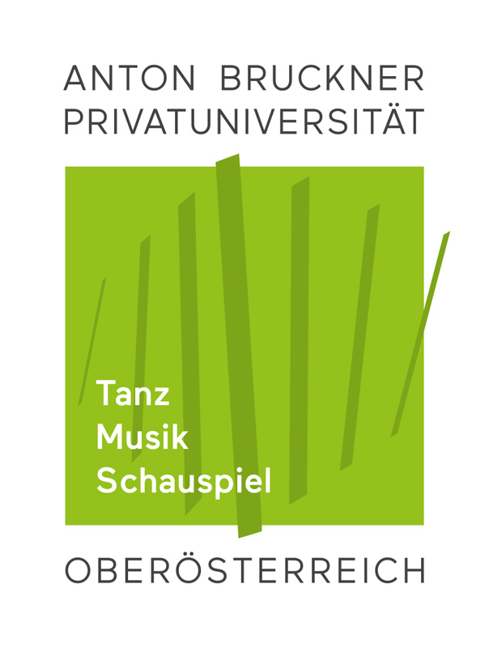

Erasmus+ Mobility STUDENT APPLICATION FORM

Academic Year (mobility period) student applies for: 2021/2022

Student
Last/family name (s): | Last name (s) | First name (s): | First name(s)
Date and place of birth: | Date and place of birth | Nationality: | Nationality
Sex [M/F/Other]: | choose an option | Phone: | Phone (incl. country code)
Current address | Current address | Permanent address  (if different): | Permanent address
Current address is valid until: | Date (if applicable) | Emergency contact: | Name, (relation), E-mail, Phone (incl. country code)
Matriculation number: | Matriculation number
E-Mail: | firstname.lastname@student.bruckneruni.at
 | 2nd private E-Mail (optional)
Other: | I receive a regular study grant (österreichische Studienbeihilfe) |  |  | ☐
 | Due to a disability, I need a grant to cover the resulting higher mobility costs |  |  | ☐
 | I apply for a subsidy for the accompaniment of children |  |  | ☐
 | I have sufficient health and accident insurance cover for the duration and scope of my mobility (e.g. a valid EHIC – European Health Insurance Card – on the rear of the e-Card) |  |  | ☐

Sending Institution
Name: | Anton Bruckner Private University | Administrative Unit: | International Relations
Institutional Erasmus Code: | A LINZ17 | Erasmus+ Coordinator: | Noémi Emma PARRAGHY
Address: | Hagenstraße 57, 4040 Linz | E-mail : | noemi.parraghy@bruckneruni.at
Country : | AUSTRIA | Phone : | +43 732 701000 206

Relevant Studies at Bruckneruni
Field of Education ISCED Code: | 0215 (Music and Performing Arts)
Study programme (relevant for your study stay): | choose an option
 | ID of Study Programme (as indicated in bonline)
Principal study subject: | Principal study subject
Study cycle: | choose an option | Study year: | 1st ☐ | 2nd ☐ | 3rd ☐ | 4th ☐
Professor in main field of study: | main subject teacher's full name
Applying to Receiving Institution (ranked by priority)
I. Receiving institution: | Host Institution’s name, city, country |  |  |  |  |  |  |  | Erasmus Code / Institutional Code
Principal study subject at the Receiving Institution |  |  |  |  |  | Main language of Instruction at the Receiving Institution |  |  | main language
Study cycle during the exchange period | Bachelor (1st) ☐ |  |  | Master (2nd) ☐ |  |  | Doctorate (3rd) ☐
Study period | 1st Semester ☐ | 2nd Semester ☐ |  |  | Academic Year ☐ |  |  | Other Period (i.e.Term) ☐
Duration of stay according to the Receiving Institution’s academic calendar | Start of the term: (dd/mm/yyyy) |  | dd/mm/yyyy |  |  | End of the term: (dd/mm/yyyy) |  |  | dd/mm/yyyy
 | Total duration in months (round up 15 or more days to a month) : minimum duration : 3 months / maximum duration : 12 months per study cycle |  |  |  |  |  |  |  | mm
Preferred teacher(s) for the main subject

II. Receiving institution: | Host Institution’s name, city, country |  |  |  |  |  |  |  | Erasmus Code / Institutional Code
Principal study subject at the Receiving Institution |  |  |  |  |  | Main language of Instruction at the Receiving Institution |  |  | main language
Study cycle during the exchange period | Bachelor (1st) ☐ |  |  | Master (2nd) ☐ |  |  | Doctorate (3rd) ☐
Study period | 1st Semester ☐ | 2nd Semester ☐ |  |  | Academic Year ☐ |  |  | Other Period (i.e.Term) ☐
Duration of stay according to the Receiving Institution’s academic calendar | Start of the term: (dd/mm/yyyy) |  | dd/mm/yyyy |  |  | End of the term: (dd/mm/yyyy) |  |  | dd/mm/yyyy
 | Total duration in months (round up 15 or more days to a month) minimum duration : 3 months / maximum duration : 12 months per study cycle |  |  |  |  |  |  |  | mm
Preferred teacher(s) for the main subject

III. Receiving institution: | Host Institution’s name, city, country |  |  |  |  |  |  |  | Erasmus Code / Institutional Code
Principal study subject at the Receiving Institution |  |  |  |  |  | Main language of Instruction at the Receiving Institution |  |  | main language
Study cycle during the exchange period | Bachelor (1st) ☐ |  |  | Master (2nd) ☐ |  |  | Doctorate (3rd) ☐
Study period | 1st Semester ☐ | 2nd Semester ☐ |  |  | Academic Year ☐ |  |  | Other Period (i.e.Term) ☐
Duration of stay according to the Receiving Institution’s academic calendar | Start of the term: (dd/mm/yyyy) |  | dd/mm/yyyy |  |  | End of the term: (dd/mm/yyyy) |  |  | dd/mm/yyyy
 | Total duration in months (round up 15 or more days to a month) minimum duration : 3 months / maximum duration : 12 months per study cycle |  |  |  |  |  |  |  | mm
Preferred teacher(s) for the main subject

Previous Studies in Erasmus Programme (if any)
Have you already been studying/working abroad as ERASMUS student/trainee? |  | Yes ☐ | No ☐
If “Yes”, please indicate: | Former Receiving Institution’s name, City, Country | Study cycle (Bachelor or Master) : | Duration of stay (in months) :

Application Package
1. Recording or Portfolio for Audition
If Receiving institution requires you to send in a (certified) recording of your audition repertoire, please ask your teacher of your main subject to certify by signing that the recording is your own performance
List of pieces performed on your Recording (music performers, also add links and indicate total length in minutes) and/or scores indicated in your Portfolio (for composers):
2. Motivation
Please attach your motivation letter(s) (one for each Receiving Institution)

3. Transcript of Records
Please attach your Transcript of Records
4. Curriculum Vitae
Please attach your CV
5. Letter of Recommendation
Please attach a signed letter of recommendation from your principal subject teacher

Student’s Language Skills

Mother tongue:
Please indicate your language skills other than mother tongue:
1. Language: Language 1 | Limited A1 ☐ A2 ☐ | Moderate B1 ☐ B2 ☐ | Fluent C1 ☐ C2 ☐
2. Language: Language 2 | Limited A1 ☐ A2 ☐ | Moderate B1 ☐ B2 ☐ | Fluent C1 ☐ C2 ☐
3. Language: Language 3 | Limited A1 ☐ A2 ☐ | Moderate B1 ☐ B2 ☐ | Fluent C1 ☐ C2 ☐
I am aware of the obligation to pass the online language test (via OLS) before my studies abroad, and I am interested in improving my language skills if recommended |  |  |  | ☐

Signatures of Sending Institution
Student: |  | Date:
Professor/Tutor  (main subject): |  | Date:
Head of Department: |  | Date:
Erasmus Coordinator: |  | Date:

NOTES FOR GUIDANCE
General Information
All enquiries and applications for exchange programmes must be made through the Erasmus Coordinator in your sending/home institution www.bruckneruni.at/en/university/international-relations/contact/ To facilitate general procedures, please use e-mail until the point of mutual confirmation/signatures.
Application form and deadline
Please complete the form as fully and as clearly as possible and bear in mind that application deadlines of your preferred receiving/host institution(s) may vary.
Other forms
Some institutions may require extra documentation with your application; you may for example be asked to complete an additional application form and/or heed a specific online application procedure.
Erasmus Code / Institutional Code
Find out the code either through the host institution’s website or EASY platform, or look it up in the brochure (PDF) in the download-section of the list of partner institutions at www.bruckneruni.at/en/university/international-relations/erasmus/erasmus-partner-institutions/

Nationality: Country to which the person belongs administratively and that issues the ID card and/or passport
E-Mail: Your Bruckneruni Student E-Mail account should be the first and main communication channel for all student-mobility related correspondence. Please state your private E-Mail account for back-up.
Insurance: Enquire at your social security provider or the ÖH in due time!
ISCED code search tool available at http://ec.europa.eu/education/tools/isced-f_en.htm should be used to find the ISCED detailed field of education and training that is closest to the subject of the degree to be awarded to the student by the sending institution
Study programme: only one course of study, i.e. either the artistic or the pedagogical part, is permitted within the framework of the Erasmus study programme. In the respective other degree programme, if applicable, an application for an extension of the duration of studies or leave of absence must be submitted at the faculty office before the start of the stay abroad.
Study cycle: Short cycle (EQF level 5) / bachelor or equivalent first cycle (EQF level 6) / master or equivalent second cycle (EQF level 7) / doctorate or equivalent third cycle (EQF level 8).
Principal study subject Only state your principal study discipline (or subject of thesis), in which you wish to be auditioned. If you wish to audition for more than one discipline, you are obligated to complete a separate application for each.
Transcript including full details of previous and current higher education study. This has to be issued by the sending institution, not to be mistaken with the final ‘transcript of records’ which will be issued by the receiving institution at the end of the exchange period.
Language competence You will normally be expected to have some proficiency in the language used for tuition in the receiving institution and you will gain most benefit from your exchange if you have some proficiency in the country’s native language.
Language skills: This information is only meant as a preliminary rating to assess the level of language proficiency. The actual level will be determined after the student’s Erasmus+ nomination by the first OLS assessment. To facilitate your rating, the given options may be regarded in rough relation to the reference levels of the Common European Framework of Reference for Languages (CEFR) from A1 (limited) to C1/2 (fluent). http://europass.cedefop.europa.eu/en/resources/european-language-levels-cefr)
Erasmus+ Open Linguistic Support (OLS) for students when mobility is taking place between Programme Countries (KA103) to assess the level of language proficiency from A1 (limited) to C1/2 (fluent). OLS is not available for International credit mobility (KA107). Coordinator of sending institution registers student for language assessment before his/her studies abroad, and registers student to the language course for improvment of the language skills if license is allocated.

